

**PROJECT REPORT**

**Online Market Place**

Submitted in partial fulfillment of the requirement for the

2st Semester of

**MASTER IN COMPUETR APPLICATION**

**TO**

**RK UNIVERSITY, RAJKOT**

## Submitted By

### Name : Kamani Rutvik Enrollment No : 22SOECA21028

## UNDER THE GUIDANCE OF

## INTERNAL GUIDE

## DR. PARESH TANNA

## Assistant Professor,

## RK University.

## Rajkot



**SCHOOL OF ENGINEERING, RK UNIVERSITY,**

**RAJKOT**



**DECLARATION**

We hereby certify that we are the sole authors of this project work and that neither any part of this project work nor the whole of the project work has been submitted for a 2st semester of MCA to any other University of Institution. We certify that, to the best of our knowledge, our project work does not infringe upon anyone’s copyright nor violate any proprietary rights and that any ideas, techniques, quotations, or any other material from the work of other people included in our project document, published or otherwise, are fully acknowledged in accordance with the standard referencing practices. We declare that this is a true copy of our project work, including any final revisions, as approved by our project review committee.

**Signature of Students Signature of Faculty**

Date:- 30/05/2023

Place:- R.K. University

**Table of Contents**

|  |  |
| --- | --- |
| **TITLE** | **PAGE NO** |
| * Acknowledgement | 04 |
| * Abstract | 05 |
| * Introduction | 06 |
| * Project summery | 06 |
| * Purpose | 06 |
| * Language introduction | 07 |
| * Project management | 09 |
| * Project development approach | 09 |
| * Project plan | 10 |
| * Schedule representation | 10 |
| * System requirement study | 12 |
| * User characteristics | 12 |
| * Hardware | 12 |
| * System analysis | 13 |
| * Study of current system | 13 |
| * Feasibility study | 13 |
| * Data dictionary | 14 |
| * Use case diagram | 17 |
| * Data modelling | 18 |
| * System design | 19 |
| * Flow chart | 19 |
| * Testing | 21 |
| * Test plan | 22 |
| * Testing strategy | 22 |
| * Testing methods | 23 |
| * Testing cases | 24 |
| * Screen short | 26 |
| * Limitation & future enhancement | 39 |
| * Conclusion and discussion | 40 |
| * References | 41 |

**Acknowledgement**

* It is out great pleasure to present our project report on **Students**

which we conceived during the MCA 2ST SEM affiliated to R.K. University.

* We take this opportunity to express our sincere gratitude and we feel immense pleasure to thank our faculty, philosopher and guide for **DR. Paresh Tanna** who helped us and gave full support in each and every way to fulfill and accomplish our project **Online Market Place**.
* We are indebted to our School of Engineering and our **HOD DR. Paresh Tanna** for given us an excellent chance to prove our best work and efforts and also suggest us to make this project in **Python-Django.**

We are mostly thankful to him, for giving us the inspiration and dedication to successfully complete this project.

**Abstract**

* The online marketplace website is an online classifieds platform, a place where people can connect with each other to buy or sell goods and services.
* The website offers a user-friendly interface with features such as product listings, search functionality and communication for interactions between buyers and sellers.
* There are various categories for all products. The administrator is responsible for the authentication of the user and product both.
* The buyers can personally chat with the seller of the product.

**Introduction**

* This project building as online marketplace website has become increasingly popular.
* The purpose of this guide is to help you decide whether online marketplaces could be a good fit for your business.
* Project Summery
* Online marketplace provides a platform where registered user can buy and sell products or items online.
* The seller can upload any item on the site in order to sell it.
* Every component on the website is under the control of the Administrator.
* The Administrator has full authority to insert, update or delete any user or product from the website.
* Purpose
  + The purpose of Marketplace system is to take advantage of the Internet and improve the way private individuals and companies buy and sell the items.
* Language Introduction
* Bootstrap
* Bootstrap is a free and open-source CSS framework directed at responsive, mobile-first front-end web development. It contains HTML, CSS and (optionally) JavaScript-based design templates for typography, forms, buttons, navigation, and other interface components.
* JavaScript
* jQuery is a JavaScript library designed to simplify HTML DOM tree traversal and manipulation, as well as event handling, CSS animation, and Ajax. It is free, open-source software using the permissive MIT License. As of Aug 2022, jQuery is used by Page 9 of 55 77% of the 10 million most popular websites.
* Python
* Python is a high-level, general-purpose programming language. Its design philosophy emphasizes code readability with the use of significant indentation. Python is dynamically-typed and garbage-collected. It supports multiple programming paradigms, including structured, object-oriented and functional programming.
* MySQL
* MySQL is an open-source relational database management system. Its name is a combination of "My", the name of cofounder Michael Wideness’s daughter My, and "SQL", the abbreviation for Structured Query Language.

**Project management**

* Project management is a distinct area of management that helps in handling projects.
* It has three key features to distinguish it from other forms of management and they include: a project manager, the project team and the project management system.
* The project management system comprises organization structure, information processing and decision making and the procedures that facilitate integration of horizontal and vertical elements of the project organization.
* The project management system focuses on integrated planning and control.
* Project Development Approach
* Project management approach will help in handling complex, costly and risky assignments by providing interdisciplinary approaches in handling the assignments.
* project management approaches help in handling assignments in a specified time frame with definite start and completion points.
* project management approaches provide task orientation to personnel in an organization in handling assignments.
* Project Planning
  + Define your project’s scope, quality baseline, deliverables, milestones, success criteria and requirements.
  + Identify risks and assign deliverables to your team members, who will perform the tasks required and monitor the risks associated with them.
  + Organize your project team and define their roles and responsibilities.
  + Develop change management procedures and forms.
  + Create a communication plan, schedule, budget and other guiding documents for the project.
* Schedule Representation
  + The implementation of the project includes various jobs/exercises such as procurement of technical know-how, market surveys and tie-ups, preparation of project report, selection of site, registration, financing of project, procurement of machinery and raw materials etc., recruitment of staff, erection/ commissioning of machines, trial production and commercial production etc.
  + In order to efficiently and successfully implement the project in the shortest period, simultaneous exercises are carried out.
  + Project implementation will take a period of 3 months from the date of approval of the scheme. Breakup of activities with relative time for each activity is shown below –

|  |  |  |  |  |  |  |
| --- | --- | --- | --- | --- | --- | --- |
| **Task Name** | **March** | | **April** | | **May** | |
| 1 to 15 | 16 to 31 | 1 to 15 | 16 to 30 | 1 to 15 | 16 to 20 |
| Planning & Research |  |  |  |  |  |  |
| Design |  |  |  |  |  |  |
| Implementation |  |  |  |  |  |  |
| Testing |  |  |  |  |  |  |
| Documentation |  |  |  |  |  |  |
| Submit |  |  |  |  |  |  |

**System requirement study**

* User characteristics
  + User requirements are typically written when discussing the use cases for a project. The requirements definition is done with the customer or product managers that know how the embedded system will be used by the user. Many user requirements deal with how a user will interact with a system and what that user expects.
* Hardware
  + Based server running any serve hundreds of unique customers each day. Low traffic sites can be easily served from a single machine depending on the needs of the business. High traffic sites require a backup of servers which automatically takes over operations in case of failure of primary ones.

**System analysis**

* Study of current system
  + System Study is a Problem-Solving technique that decomposed a system into its component pieces for the purpose of the studying how well those component parts work and interact to accomplish their purpose.
  + According to the Merriam-Webster dictionary, systems analysis is the process of studying a procedure or business in order to identify its goals and purposes and create systems and procedures that 5ill achie1e them in an efficient Way.
  + Analysis and synthesis, as scientific methods, always go hand in hand; they complement one another. Every synthesis is built upon the results of a preceding analysis, and every analysis requires a subsequent synthesis in order to verify and correct its results.
* Feasibility study
  + Whatever we think need not be feasible. It is wise to think about the feasibility of any problem we undertake. Feasibility is the study of impact, which happens in the organization by the development of a system. The impact can be either positive or negative. When the positives nominate the negatives, then the Page 16 of 55 system is considered feasible. Here the feasibility study can be performed in two ways such as technical feasibility and Economical Feasibility.
  + The developing system must be justified by cost and benefit. Criteria to ensure that effort is concentrated on project, which will give best, return at the earliest. One of the factors, which affect the development of a new system, is the cost it would require.
  + Since the system is developed as part of project work, there is no manual cost to spend for the proposed system. Also all the resources and already available, it given an indication of the system is economically possible for development.
* Data Dictionary
  + Database :- puddle

Table : - User

|  |  |  |  |
| --- | --- | --- | --- |
| **NO** | **NAME** | **TYPE** | **CONSTRUCTOR** |
| 1 | Id | Bigint(20) | Primary key |
| 2 | First_name | Varchar(150) |  |
| 3 | Last_name | Varchar(150) |  |
| 4 | Email | Varchar(150) |  |

Table : - contact

|  |  |  |  |
| --- | --- | --- | --- |
| **NO** | **NAME** | **TYPE** | **CONSTRUCTOR** |
| 1 | Id | Bigint(20) | Primary key |
| 2 | Fname | Varchar(50) |  |
| 3 | Lname | Varchar(50) |  |
| 4 | Email | Varchar(50) |  |
| 5 | Contact | Varchar(50) |  |
| 6 | Message | Longtext |  |

Table :- category

|  |  |  |  |
| --- | --- | --- | --- |
| **NO** | **NAME** | **TYPE** | **CONSTRUCTOR** |
| 1 | Id | Bigjnt(20) | Primary key |
| 2 | Name | Varchar(150) |  |

Table :- item

|  |  |  |  |
| --- | --- | --- | --- |
| **NO** | **NAME** | **TYPE** | **CONSTRUCTOR** |
| 1 | Id | Bigint(20) | Primary key |
| 2 | Name | Varchar(150) |  |
| 3 | Description | Longtxt |  |
| 4 | Price | Double |  |
| 5 | Image | Varchar(100) |  |
| 6 | Is_sold | Tinyint(1) |  |
| 7 | Created_at | Datetime(6) |  |
| 8 | Categoty_id | Bigint(20) | Foreign key |
| 9 | User_id | Int(11) | Foreign key |

Table :- conversation

|  |  |  |  |
| --- | --- | --- | --- |
| **NO** | **NAME** | **TYPE** | **CONSTRUCTOR** |
| 1 | Id | Bigint(20) | Primary key |
| 2 | Created_at | Datetime(6) |  |
| 3 | Modified_at | Datetime(6) |  |
| 4 | Item_id | Bigint(20) | Foreign key |

Table :- conversation message

|  |  |  |  |
| --- | --- | --- | --- |
| **NO** | **NAME** | **TYPE** | **CONSTRUCTOR** |
| 1 | Id | Bigint(20) | Primary key |
| 2 | Content | Longtext |  |
| 3 | Created_at | Datetime(6) |  |
| 4 | Conversation_id | Bigint(20) | Foreign key |
| 5 | User_id | Int(11) | Foreign key |

Table :- conversation member

|  |  |  |  |
| --- | --- | --- | --- |
| **NO** | **NAME** | **TYPE** | **CONSTRUCTOR** |
| 1 | Id | Bigint(20) | Primary key |
| 2 | Conversation_id | Bigint(20) | Foreign key |
| 3 | User_id | Int(11) | Foreign key |

* Use case diagram

Use-case-diagram for Customer

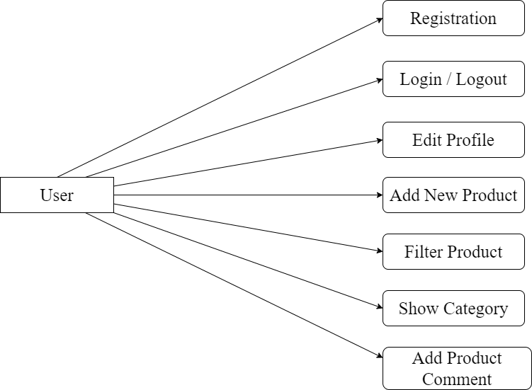

Use-case-diagram for Admin

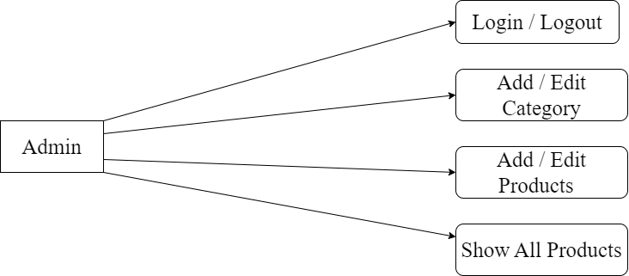

* Data modelling
  + A data model shows the client’s information needs and business processes through entities, relationships and data required within the system. It complements the data flow diagram which shows how the data is processed.
  + Data models can be conceptual (high level entities and relationships to document business concepts or high Level requirements), logical (more detailed information on entities, attributes and relationships by often expanding the conceptual model to include attributes, columns, fields and keys) or physical (how data is stored and managed in an application).
  + Data models are diagrams supported by textual descriptions. They can include people, places, things, concepts, attributes and relationships. Textual descriptions are usually included in a data dictionary.

**System design**

* Flow Chart
* 0 Level

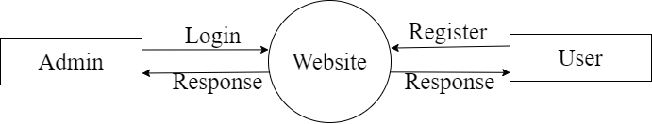

* 1 Level

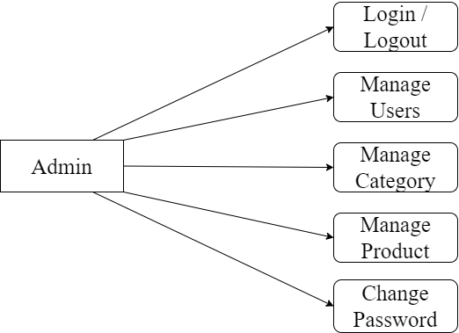

* 2 Level

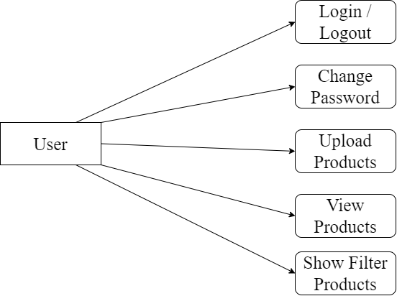

**Testing**

* Software testing is the process of evaluating and verifying that a software product or application does what it is supposed to do. The benefits of testing include preventing bugs, reducing development costs and improving performance.
* Test Plan
* Like any project, the testing also should be driven by a plan. The test plan generates the report for the execution and tracking of the entire testing project.
* Preparing the test plan
  + What needs to be the tested-the scope of testing, including clear identification of what will be the tested & what will not be tested.
  + How the testing is going to be performed -breaking down the testing into small and manageable tasks and identifying the strategies to be used for carrying out the tasks.
  + Resource needed for testing.
  + The timelines by which the testing activities will be performed.
  + Risks that may be faced in all of the above, with appropriate Page 25 of 55 mitigation and contingency plans.
* Testing Strategy
* Writing a Test Strategy effectively is a skill that every tester should achieve in their career. It initiates your thought process that helps to discover many missing requirements. Thinking and test planning activities help the team to define the Testing scope and Test coverage.
* It helps Test managers to get the clear state of the project at any point. The chances of missing any test activity are very low when there is a proper test strategy in place.
* Test execution without any plan rarely works. I know teams who write strategy document but never refer back while test execution. The Testing Strategy plan must be discussed with the whole team so that the team will be consistent with its approach and responsibilities.
* In tight deadlines, you can’t just waive any testing activity due to time pressure. It must at least go through a formal process before doing so.
* Testing methods
* Testing methodologies are the strategies and approaches used to test a particular product to ensure it is fit for purpose. Testing methodologies usually involve testing that the product works in accordance with its specification, has no undesirable side effects when used in ways outside of its design parameters, and will fail safely in the worst-case scenario.
* As software applications get ever more complex and intertwined and with the large number of different platforms and devices required to test, it is more important than ever to have a robust testing methodology.
* Without the proper development and testing methodologies for modern software, projects will inevitably go over budget, take longer than necessary, and not meet stakeholder expectations.
* Two Types of Testing

1. Blackbox Testing

Blackbox Testing can be used to validate the report meets all the specified requirements. Testers can review the report against the project objectives and deliverables to ensure that they are adequately addressed.

1. Whitebox Testing

Whitebox Testing for a project report involves examining the structure and organization of the document. Testers analyse how well the report is structured, including the logical flow of sections, of information, and the overall organization.

* Testing Cases

|  |  |
| --- | --- |
| **Test Case Specification** | **Description** |
| Test Case ID | Unique ID to identify/report the bug if present in the functionality of software |
| Test Case Objective | The purpose of the test. The lists can be generated to perform intended task for which software is developed. Results should always follow the test case objective |
| Pre-requisite | This can include environment setup, supporting software environment setup. for the project, or any fields in which user will give the input. So that test cases can be planned accordingly. |
| Steps | This includes steps to be performed to give the input to the system, so that system can perform its specified task and display the result accordingly. If automated testing is used, then, these steps are translated to the scripting language of the tool. |
| Input Data | The choice of input data will be depended on the test case itself and the technique followed in the test case. For E.X. equivalence partitioning, boundary value analysis etc. |
| Expected Result | It can be the user required output to be shown |
| Actual Result | This step should do a comparison of the expected and actual results to highlight any differences. |
| Status | Whether expected results and actual result match, if it matches then PASS or else FAIL |

**Screen Short**

* Home Page

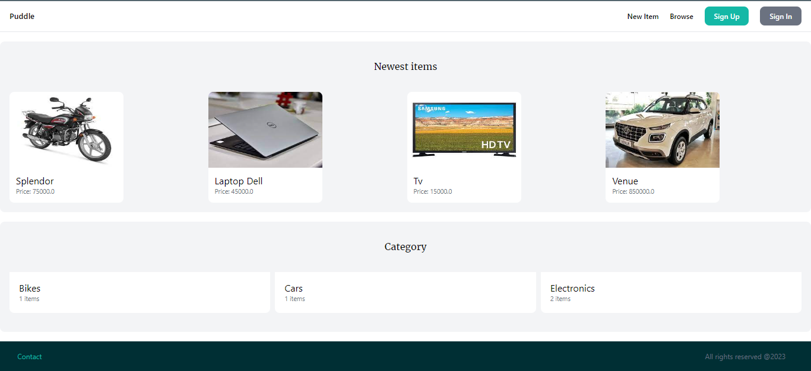

This is Home Page

* Browse Filter

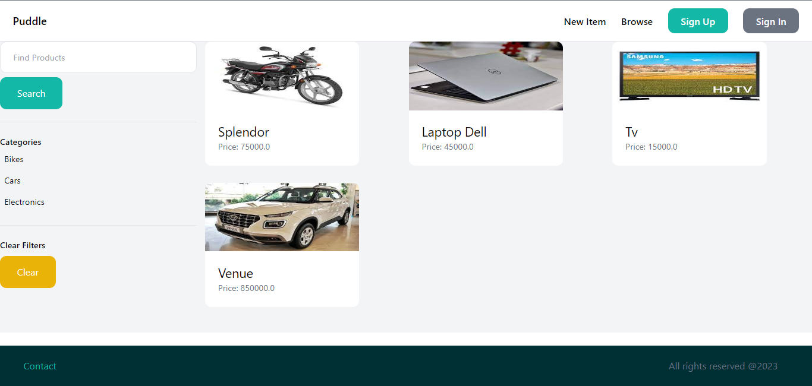

This is Product Browse Page

* Sign Up

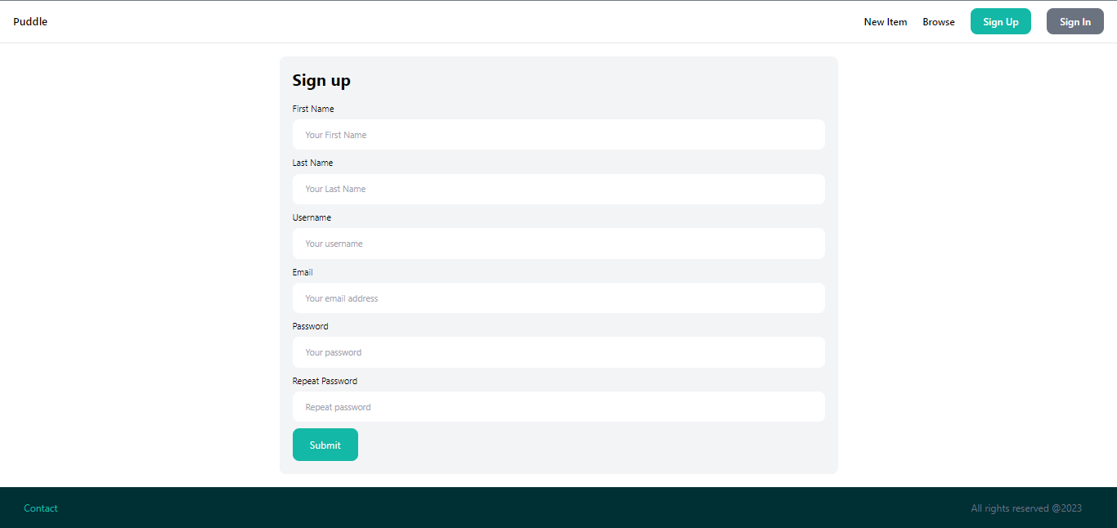

This is User Sign Up Page

* Sign In

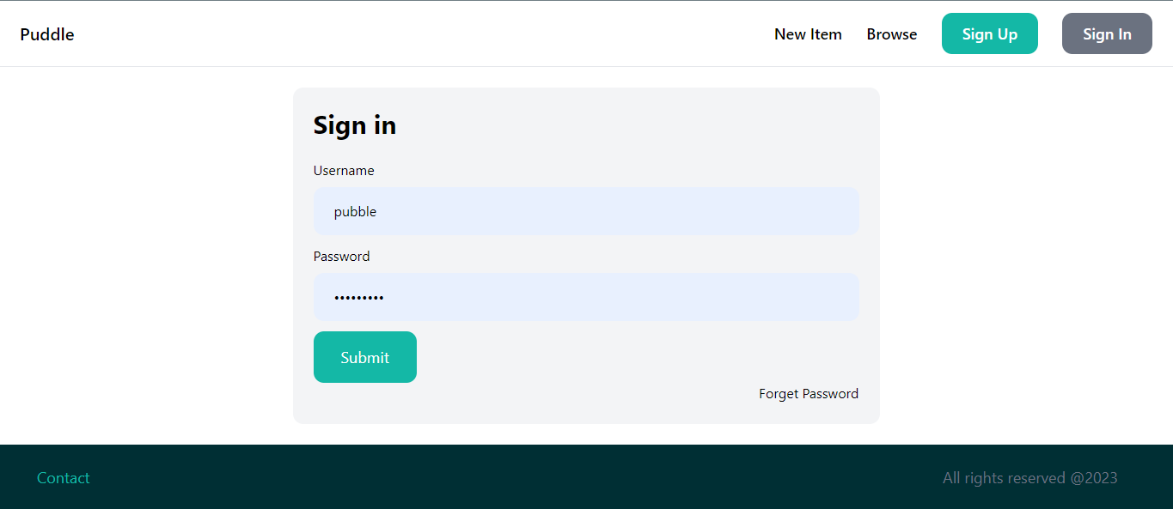

This is Sign In Page

* Add New Product

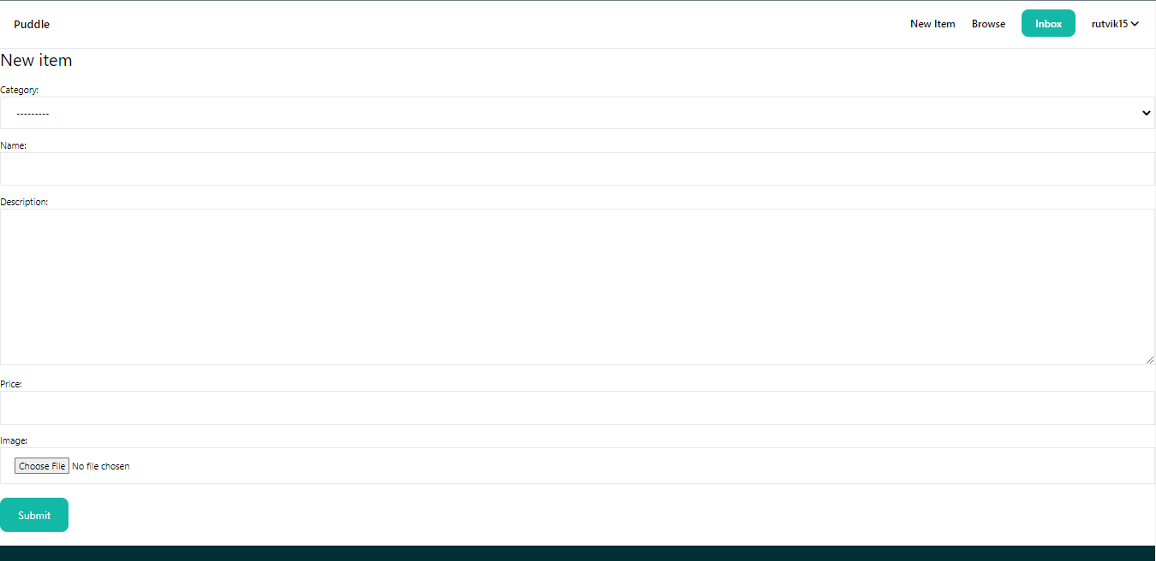

This is Add product page

* Contact Page

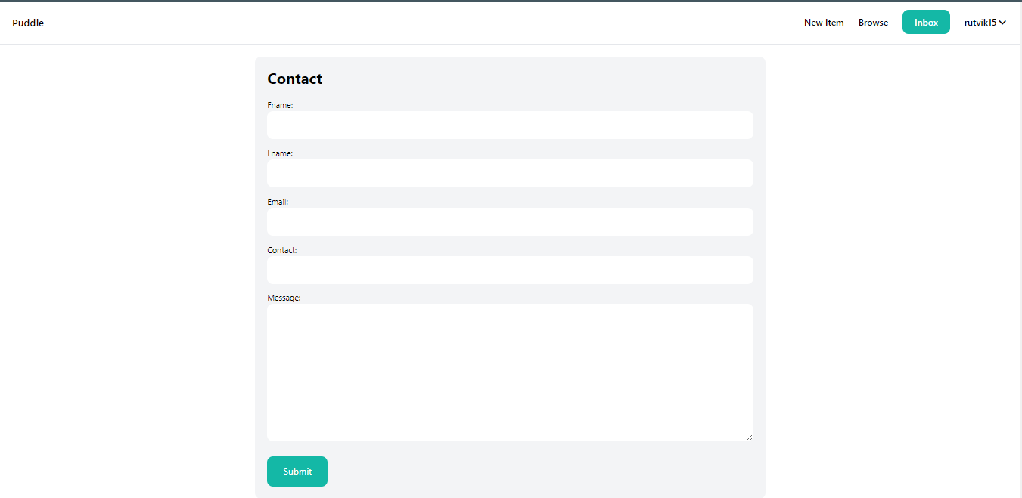

This is Contact Page

* Product Details Page

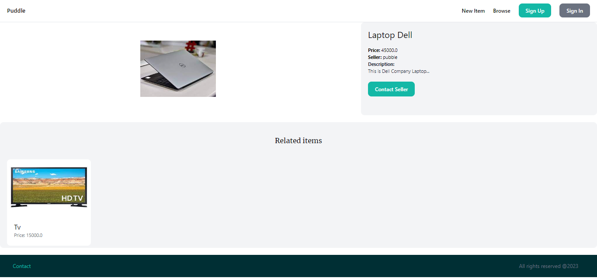

This is Product Details Page

* Admin Panel

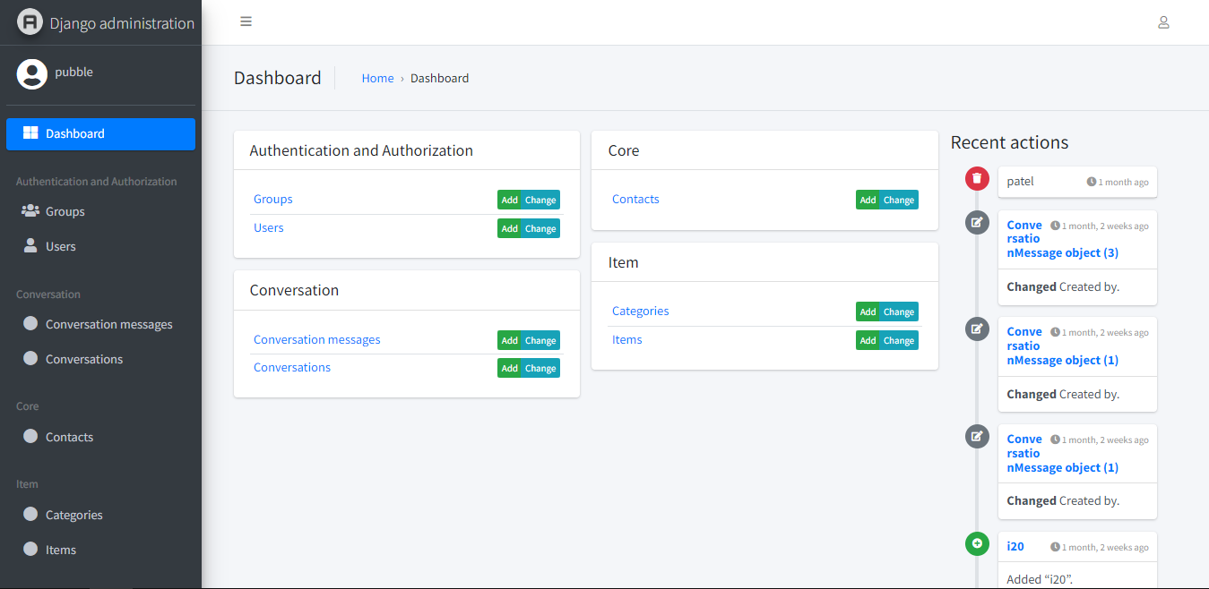

This is Show Admin Panel Page

* Add Category

This is add category page

* Product Page

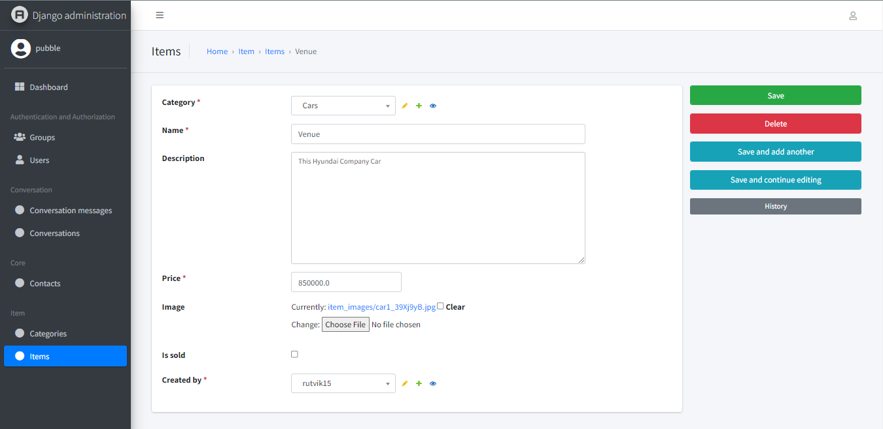

This is show product details page

* Contact Us Page

This is show user contact page

* Conversation Page

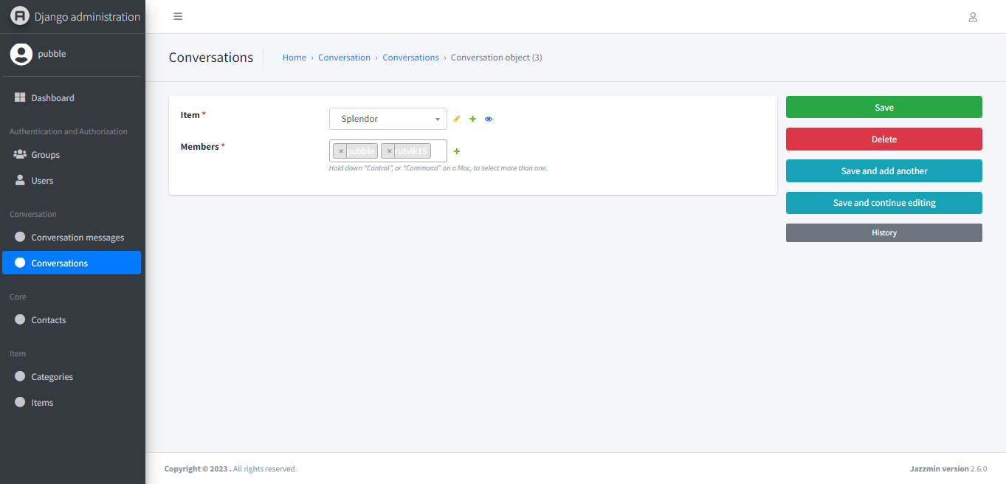

This is person conversation page

* Conversation Messages Page

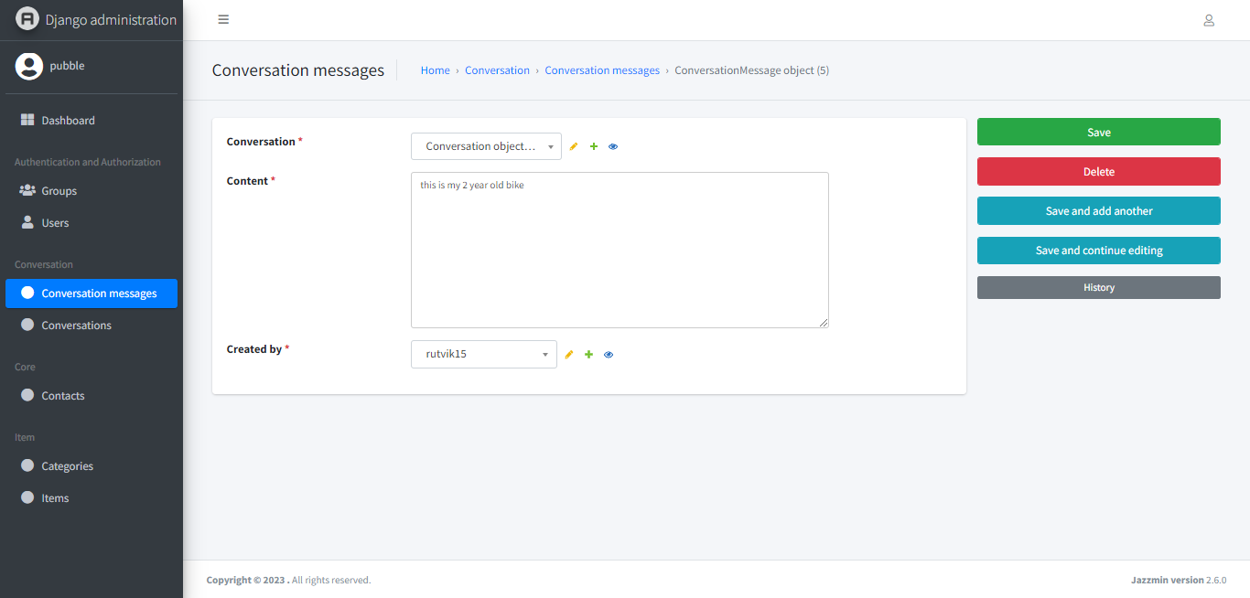

This is show conversation message page

**Limitation & future enhancement**

* Many online marketplace have basic search capabilities, which can make it difficult for users to find specific products or services. Future enhancement could include implementing advanced search filters, keyword suggestions, and personalized recommendations to improve the search experience.
* Ineffective communication channels between buyers and sellers. Improvements may involve integrating a messaging system, chatbots, or smooth communication and enhance the overall user experience.
* Online marketplaces can benefit from integrating social media features, allowing users to share products, engage with the community, and promote their listings through social channels. This can enhance visibility, attract new users, and foster a sense of community within the platform.
* Online marketplaces often provide a generic user experience. Feature enhancements could include personalizing product recommendations based on user preferences and browsing history, enabling users to create personalized profiles, and allowing customization of the interface to suit individual preferences.

**Conclusion and discussion**

* In conclusion, online marketplace websites provide a platform for buyers and sellers to connect and conduct transactions over the internet.
* While these platforms offer convenience and opportunities for businesses and individuals, they also face certain limitations that can hinder the user experience and overall success of the marketplace.
* Some common limitations include limited search functionality, lack of trust and security measures, inefficient communication channels, limited payment options, lack of customization and personalization, inadequate mobile experience, insufficient analytics and reporting tools, scalability and performance issues, limited social integration, and the absence of localized features.
* Ultimately, the success of an online marketplace relies on continuous improvement and adaptation to meet the evolving needs and expectations of users.
* It requires a balance between usability, security, and scalability, while leveraging innovative technologies and user-centered design principles.

**References**

* Search Engines
  + <https://www.google.com/>
* Visited Sites
  + <https://docs.djangoproject.com/en/4.1/>
  + <https://github.com/>
  + <https://www.geeksforgeeks.org/django-tutorial/>
  + <https://stackoverflow.com/>